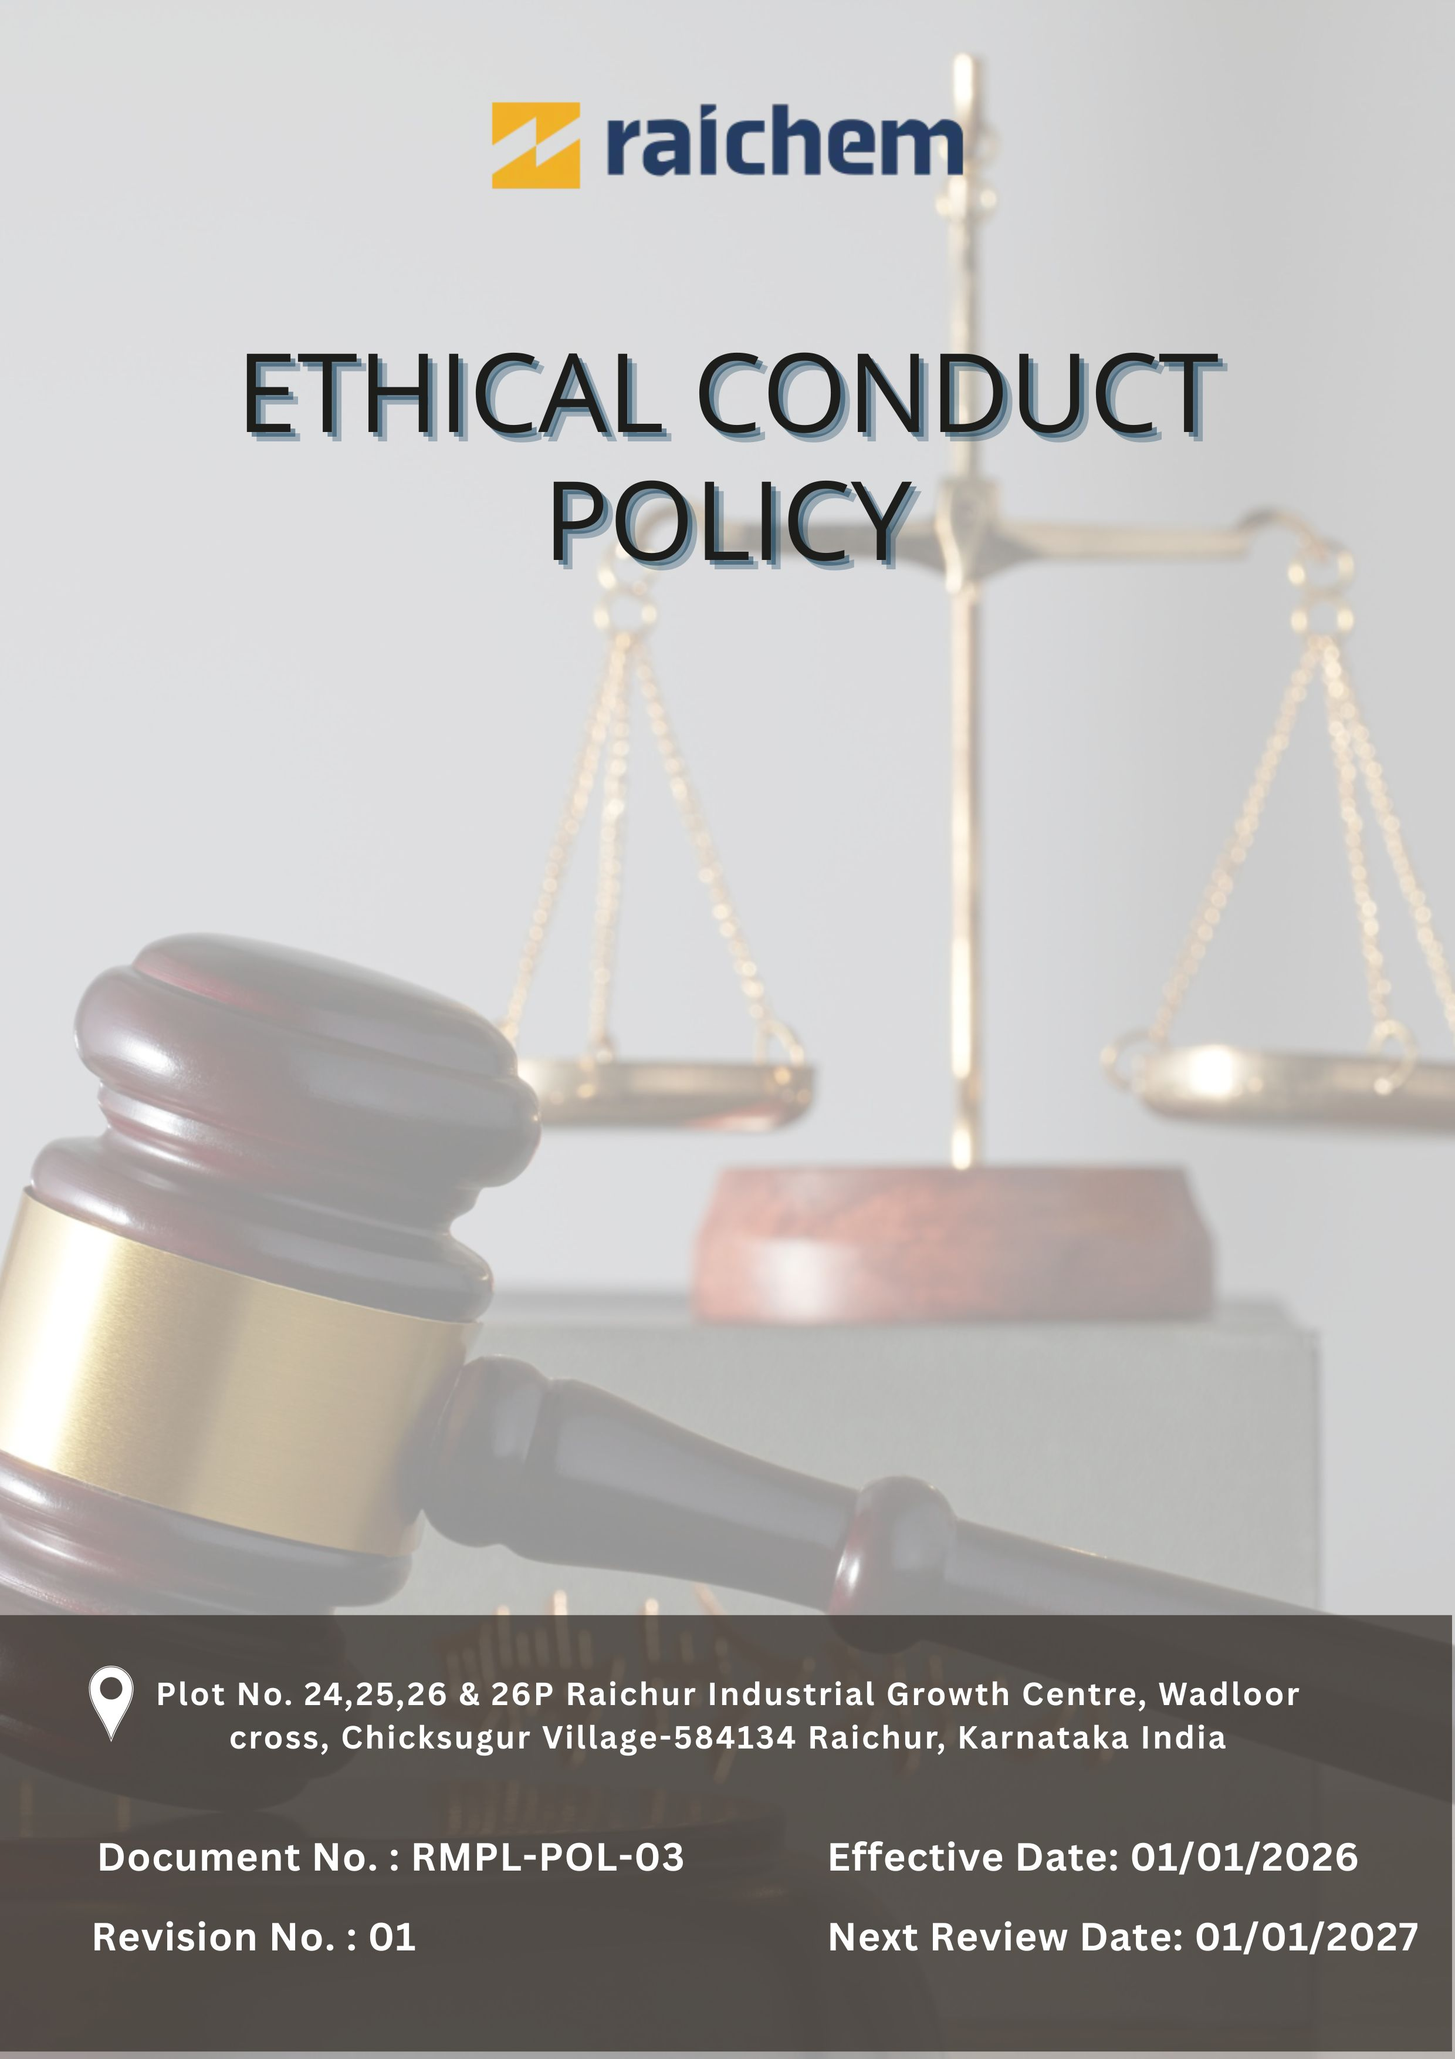
Contents

Preface 3
Policy Declaration 3
Scope 3
Key Focus Areas 4
Qualitative Objectives 4
Quantitative Targets 6
Alignment with the United Nations Sustainable Development Goals (SDGs) 7
Examples and Guidance 8
Continuous Improvement 9
Addressing Policy Violations 10
Responsibilities 11
Review Mechanism 12
Employee Acknowledgment Form 13

ETHICAL CONDUCT POLICY

Preface
Raichem Medicare Pvt. Ltd., an ICE Pharma company, is committed to maintaining the highest standards of ethical conduct, integrity, and compliance across all aspects of its business. As a responsible manufacturer of pharmaceutical ingredients, Raichem recognises that ethical behaviour is fundamental to sustaining trust with employees, customers, suppliers, regulators, and other stakeholders, and to supporting long-term business resilience. In alignment with the broader ICE Pharma sustainability strategy, the Ethical Conduct Policy establishes principles and expectations that guide decisions and behaviour throughout the organisation and its supply chain. This policy reinforces Raichem’s dedication to lawful and transparent operations, responsible business practices, and the continual promotion of ethical standards in every interaction and business relationship.

Policy Declaration
Raichem establishes this Ethical Conduct Policy to ensure that all business activities are conducted with integrity, fairness, and accountability. The Company requires employees, management, and business partners to comply with applicable laws, internal policies, and recognised standards of ethical conduct. Raichem maintains zero tolerance for bribery, corruption, fraud, conflicts of interest, or any other unethical practices, and promotes a culture of transparency and responsible decision-making across all operations and business relationships.

Scope
This Ethical Conduct Policy applies to all employees, contractual staff, consultants, and business partners of Raichem and governs conduct across all functions and operations, including manufacturing, quality assurance, supply chain activities, sales, and customer engagement. The policy also extends to interactions with vendors, suppliers, service providers, and other external stakeholders, ensuring that all business relationships are conducted in alignment with the Company’s values of integrity, transparency, and ethical responsibility.
This policy is applicable to:

Site | Address
Raichem Medicare Pvt. Ltd. | Plot No. 24,25,26 & 26P Raichur Industrial Growth Centre, Wadloor cross, Chicksugur Village 584134 Raichur, Karnataka, India

Key Focus Areas
- Anti-Corruption: Prohibit bribery, kickbacks, and all forms of corrupt practices through clear standards, training, and enforcement.
- Conflict of Interest: Disclose and manage any personal or financial interests that could affect business decisions.
- Fraud Prevention: Detect and prevent fraud using internal controls, audits, and confidential reporting channels.
- Anti-Money Laundering (AML): Comply with AML laws by monitoring transactions, identifying suspicious activities, and providing training.
- Information Security: Safeguard confidential data through access controls, security measures, and awareness programs.
- Responsible Use of Company Assets: Ensure assets are used responsibly, efficiently, and solely for legitimate business purposes.

Qualitative Objectives
- Anti-Corruption
- Maintain a zero-tolerance approach to bribery, kickbacks, or any form of corrupt practices in line with applicable laws and Company policies.
- Promote a culture of integrity in which employees and business partners understand the obligation to reject bribery and unethical conduct.
- Provide periodic anti-corruption training and guidance to employees and relevant third parties.
- Encourage the reporting of suspected corruption through confidential reporting channels without fear of retaliation.

- Conflict of Interest
- Establish clear processes for identifying, disclosing, and managing actual or potential conflicts of interest in a fair and impartial manner.
- Ensure that business decisions are objective, unbiased, and free from improper personal or financial influence.
- Maintain transparency in relationships with suppliers, customers, and partners by documenting conflicts and mitigation measures.

- Fraud Prevention
- Implement internal controls, audits, and monitoring mechanisms to prevent, detect, and address fraudulent activities.
- Encourage prompt reporting of suspected fraud or irregularities through confidential reporting mechanisms.
- Investigate all reported incidents in a timely manner and take appropriate corrective or disciplinary actions.

- Anti-Money Laundering (AML)
- Comply with all applicable anti-money laundering laws, regulations, and internal procedures to prevent misuse of Company operations.
- Ensure employees are aware of AML obligations, including transaction monitoring and identification of suspicious activities.
- Maintain accurate and complete records of transactions to support transparency and regulatory compliance.

- Information Security
- Safeguard confidential business, employee, and stakeholder information through appropriate access controls and cybersecurity measures.
- Regularly assess and strengthen data protection practices to address evolving risks and regulatory requirements, ensuring secure handling, storage, and disposal of information.
- Restrict access to sensitive information based on role-based and need-to-know principles.
- Promote awareness of information security responsibilities through ongoing employee training.

- Responsible Use of Company Assets
- Ensure Company assets are used responsibly, ethically, and only for authorised business purposes.
- Encourage employees to promptly report any suspected misuse, loss, or damage to Company assets.

Quantitative Targets
FY 2022-23 serves as the baseline for all ethical governance targets at Raichem Medicare Pvt. Ltd., including those related to business integrity, anti-corruption, conflict of interest, fraud prevention, and anti-money laundering. Progress will be measured against this baseline to ensure continuous improvement through years with the targets set for FY 2029-30.

- Anti-Corruption
- Ensure that 100% of supplier and business partner contracts include anti-bribery and anti-corruption clauses by FY 2029–30.
- Maintain zero confirmed incidents of corruption identified through internal or external audits on an annual basis.
- Provide annual anti-corruption training to 100% of employees in procurement, finance, and senior management through FY 2029–30.

- Conflict of Interest
- Achieve 100% completion of conflict-of-interest declarations by all managers, key decision-makers, and Board members by FY 2029–30.
- Ensure that 100% of new employees complete conflict-of-interest awareness and disclosure requirements as part of onboarding processes.
- Ensure 100% of identified conflicts assessed and mitigated within 30 days.

- Fraud Prevention
- Review and strengthen fraud detection mechanisms and internal controls to cover 100% of critical processes by FY 2029–30.
- Maintain zero confirmed fraud incidents across all operations in each financial year.
- Conduct annual fraud risk assessments covering 100% of all functions by FY 2029–30.

- Anti-Money Laundering (AML)
- Conduct two AML audits covering 100% of relevant business units to identify and mitigate AML-related risks by FY 2029–30.
- Implement transaction monitoring and suspicious activity detection mechanisms covering 100% of high-risk operations by FY 2029–30.
- Maintain confidential reporting channels for AML-related concerns accessible to 100% of employees.

- Information Security
- Maintain zero incidents of unauthorized data access or data breaches through strengthened access controls and monitoring by FY 2029–30.
- Implement continuous monitoring systems to identify security vulnerabilities and cyber threats across 100% of critical IT systems by FY 2029–30.
- Ensure 100% of employees complete data protection and cybersecurity awareness training by FY 2029–30 and annually thereafter.

- Responsible Use of Company Assets
- Ensure that 100% of employees responsible for handling sensitive or high-value assets receive annual training on proper use and safeguarding by FY 2029–30.

Alignment with the United Nations Sustainable Development Goals (SDGs)
The sustainability objectives and performance targets align with the following Sustainable Development Goals (SDGs):
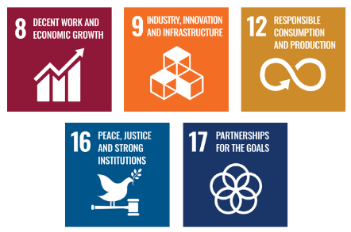

Examples and Guidance
To support consistent understanding and implementation of this Ethical Conduct Policy, the following topic-wise examples and guidance offer practical interpretations of expectations and actions:

- Anti-Corruption
- Example: A supplier offers a cash incentive or expensive gift to a company employee in exchange for influencing a tender decision.
- Guidance: The employee must refuse the offer and immediately report it to the Compliance Officer. Accepting or ignoring such offers violates the Raichem’s zero-tolerance policy on bribery and undermines fair competition.
- Conflict of Interest
- Example: A manager is involved in selecting a vendor where a close family member has a financial interest.
- Guidance: The manager must disclose the conflict immediately and recuse themselves from the decision-making process to ensure objectivity and transparency.

- Fraud Prevention
- Example: An employee alters expense claims or financial records to receive reimbursement for personal expenses.
- Guidance: Such conduct is strictly prohibited and must be reported to Finance or Compliance for investigation. Fraud damages trust, violates company policy, and may lead to disciplinary and legal action.

- Anti-Money Laundering (AML)
- Example: A client requests breaking a large wire transfer into smaller payments to avoid regulatory reporting.
- Guidance: This is a potential money laundering red flag. The transaction must be reported and reviewed according to AML procedures. Employees must be trained to recognize and respond to suspicious financial behavior without delay.

- Information Security
- Example: An employee shares confidential business data or customer information with an unauthorized third party or through unsecured email.
- Guidance: Confidential and personal data must only be shared through approved secure channels and with authorized persons. Any suspected data breach must be reported immediately to IT or Compliance.

- Responsible Use of Company Assets
- Example: An employee uses company vehicles, IT systems, or funds for personal business or unauthorized activities.
- Guidance: Company assets must be used only for legitimate business purposes. Misuse should be reported to HR and may result in disciplinary action.

Continuous Improvement
At Raichem Medicare Pvt. Ltd. Ethical Conduct practices are continuously enhanced to stay aligned with evolving regulations, industry standards, and emerging risks. A strong culture of integrity is embedded across all levels of the organization, ensuring transparency, accountability, and regulatory compliance.

- Ongoing Training & Awareness: Raichem conducts regular ethics, anti-corruption, AML, fraud prevention, and data protection training for employees and relevant external stakeholders. Training programs are updated periodically to reflect regulatory changes, emerging risks, and lessons learned from internal reviews and incidents.
- Risk Assessments & Independent Audits: Periodic ethics and compliance risk assessments are carried out to identify potential vulnerabilities related to corruption, fraud, conflicts of interest, money laundering, and information security. Independent internal and external audits are used to validate controls, verify compliance, and recommend improvements.
- Collaborative Compliance Engagement: Partnerships with internal and external stakeholders strengthen ethical standards and compliance through structured assessments, engagement, and continuous improvement actions.
- Advanced Monitoring & Reporting Systems: The company maintains systems to monitor high-risk transactions, compliance indicators, incidents, and policy adherence. Key metrics are reviewed regularly by management to ensure early detection of risks, timely response, and continuous strengthening of controls.
- Feedback & Transparency Culture: Raichem encourages open feedback, ethical dialogue, and reporting of concerns without fear of retaliation. Whistleblowing and grievance mechanisms are promoted actively, and aggregated findings and improvements are communicated transparently to reinforce trust and accountability.

Addressing Policy Violations
Raichem Medicare Pvt. Ltd. maintains a zero-tolerance approach toward violations of its Ethical Conduct Policy. All suspected or confirmed breaches will be handled seriously, fairly, and in a timely manner to uphold the company’s values of integrity, transparency, and accountability.
- Reporting Violations: All employees, contractors, and business partners are encouraged to report suspected or actual violations of this policy through designated confidential channels, including the Compliance function, HR, or the whistleblowing mechanism. Reports may be made anonymously where permitted by law and will be treated with strict confidentiality.
- Investigation Process: All reported concerns are assessed and investigated promptly and objectively by the Compliance function, in coordination with Legal and HR where appropriate. Investigations are conducted fairly, respecting due process, confidentiality, and the rights of all parties involved.
- Corrective Actions: Confirmed violations result in appropriate corrective and disciplinary actions, which may include process improvements, retraining, formal warnings, termination of employment or contracts, and, where required, legal action. Root causes are addressed to prevent recurrence.
- Protection from Retaliation: Retaliation against any individual who reports concerns in good faith or participates in an investigation is strictly prohibited. Any act of retaliation will be treated as a serious policy violation and subject to disciplinary action.

Responsibilities
At Raichem Medicare Pvt. Ltd., upholding ethical conduct is a collective responsibility:
- Compliance Officer: Ensures implementation of ethical policies and compliance with anti-corruption, conflict of interest, fraud, and information security standards.
- HR Manager: Oversees employee training on ethical conduct, including anti-corruption and conflict-of-interest policies.
- IT Manager: Safeguards company and customer data through secure information systems.
- Internal Audit Team: Conducts audits to assess policy compliance and identify risks.
- Senior Management: Reviews ethical performance, allocates resources, and promotes a culture of integrity.

Review Mechanism
The Ethical Conduct Policy is reviewed annually by the Compliance Officer to ensure its continued relevance, effectiveness, and alignment with legal and regulatory requirements. Updates may be made based on audit findings, changes in applicable laws, employee feedback, or evolving business practices. Any revisions are communicated to all employees, and necessary training is provided to ensure awareness and compliance.
Effective Date | : 01.01.2026
Next Review Date | : 01.01.2027
Revision No. | : 01

Approved By:

Employee Acknowledgment Form
I acknowledge that I have received, read, and understood the Ethical Conduct Policy of Raichem Medicare Pvt. Ltd. to uphold the principles set forth in the policy, including preventing bribery and corruption, identifying and disclosing conflicts of interest, preventing fraud, complying with anti-money laundering regulations, and protecting confidential company and client information.
I understand that it is my duty to follow this policy in all professional conduct and to report any suspected violations or unethical behavior through the company’s confidential whistleblower system or other designated channels. I am aware that any breach of this policy may result in appropriate disciplinary action agree as per company guidelines.
By signing this declaration, I confirm my personal commitment to maintaining ethical behavior, accountability, and transparency in all my responsibilities at Raichem Medicare Pvt. Ltd.

Employee Name | : _________________________
Employee ID | : _________________________
Department | : _________________________
Signature | : _________________________

